**United States Department of Agriculture**

Food and Nutrition Service

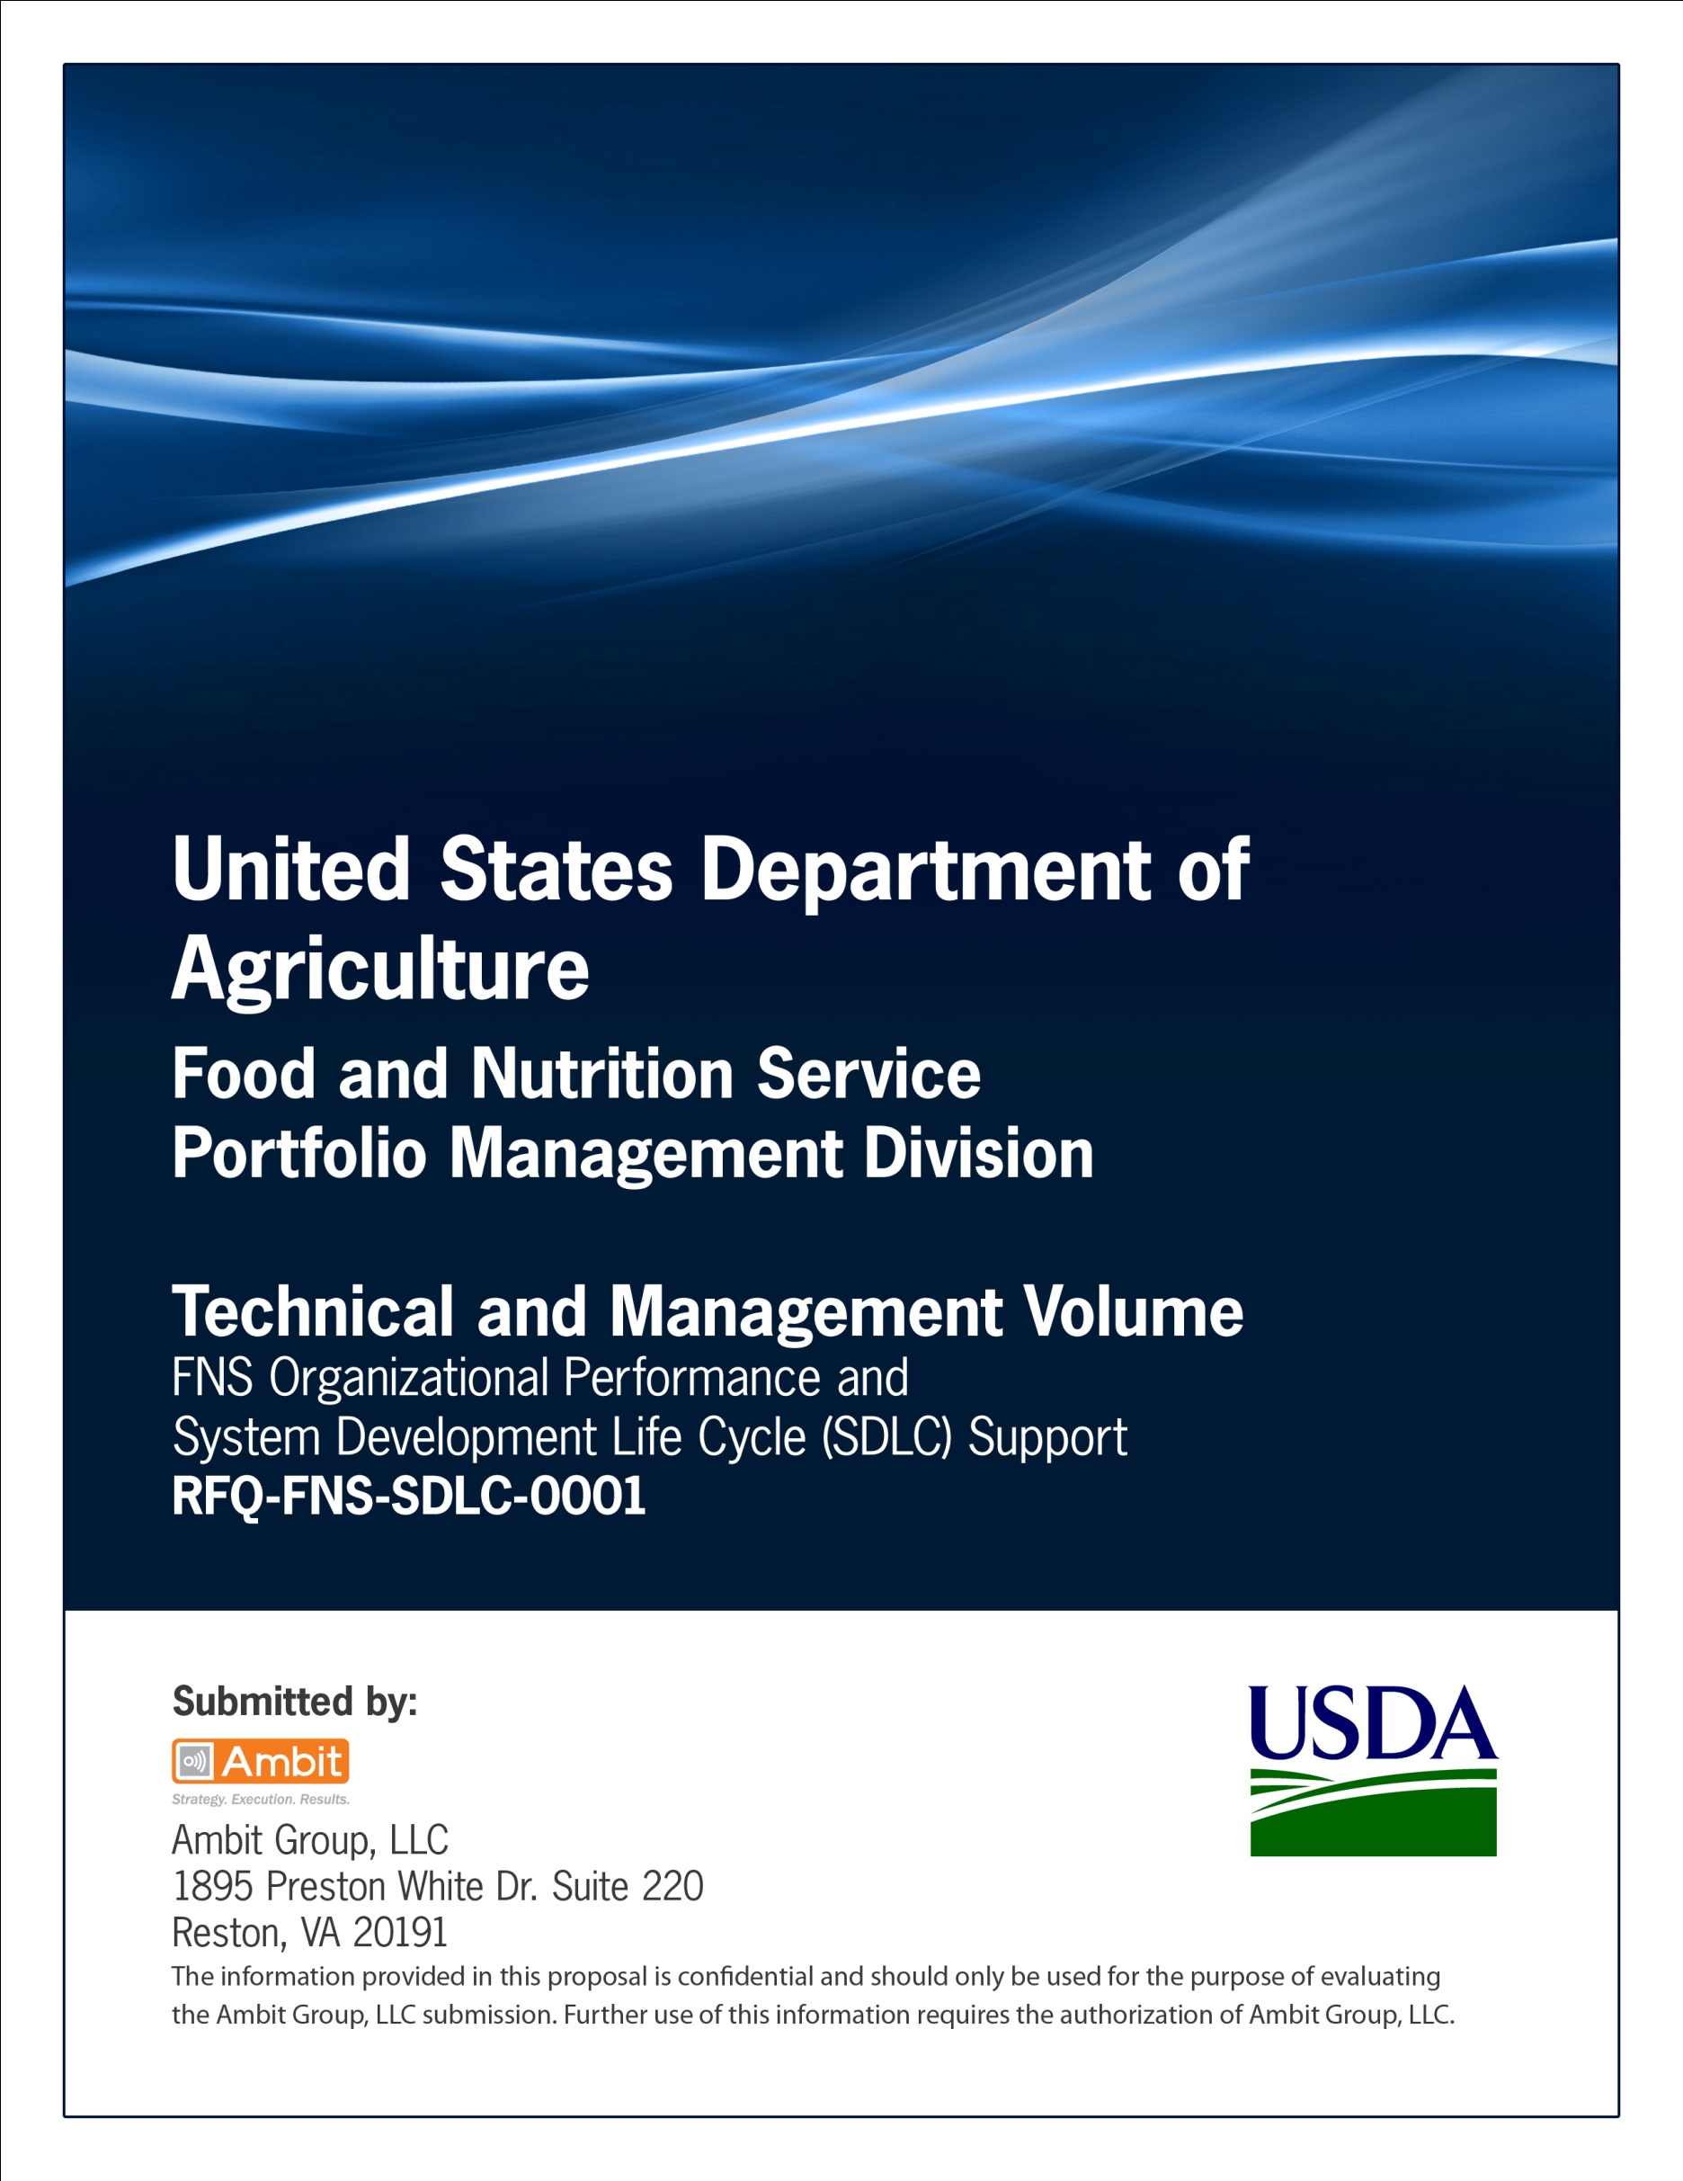

**FNS Office of Information Technology**

**Portfolio Management Division (PMD)**

**FNS Operations and Maintenance Manual Template**

**for**

**[Project or System Name]**

**Version 1.1**

September 09, 2013

**Revision History**

|  |  |  |  |
| --- | --- | --- | --- |
| **Version** | **Date** | **Author** | **Change Description** |
| 1.0 | 03-13-2013 | IT Governance Branch (ITGB) | Created the document. |
| 1.1 | 09-09-2013 | IT Governance Branch (ITGB) | Re-formatted the document. |
| 1.2 |  |  |  |
| 1.3 |  |  |  |

**Contact Information**

|  |  |
| --- | --- |
| **Area of Concern** | **Contact Person** |
| IT Governance Lead | Kevin Russ |
| SDLC Coordinator | Syed Jaffery |
| ITIRB Coordinator | Sunny Dilawari |
| Portfolio Management Division Director, Chief Portfolio Officer | Jacqueline Butler |
| Program Management Branch Chief | Allison Willcox |

Contents

Glossary 4

1. General Information 5

1.1. System Overview 5

1.2. Authorized Use Permission 5

1.3. Points of Contact 5

2. System Operations Overview 5

2.1. System Operations 5

2.2. Software Inventory 5

2.3. Information Inventory 5

2.4. Operational Inventory 5

2.5. Storage Requirements 6

2.6. Processing Overview 6

2.7. System Architecture 6

2.8. Communications Overview 6

2.9. Security 6

3. Operation Description 6

3.1. System Inventory 6

3.2. System Descriptions 6

4. System Maintenance Procedures 7

4.1. Responsibilities 7

4.2. Conventions 7

4.3. Error Conditions 7

4.4. Maintenance Procedures 7

5. Database Maintenance Procedures 7

Appendix A: Application Server Requirements 8

Appendix B: Database Server Requirements 9

Appendix C: Web Server Requirements 10

Appendix D: References 11

Approvals/Signatures 12

# Glossary

| **Acronym** | **Description** |
| --- | --- |
|  |  |
|  |  |
|  |  |
|  |  |
|  |  |
|  |  |
|  |  |
|  |  |

# General Information

## System Overview

Describe the system overview.

## Authorized Use Permission

Describe the document overview.

## Points of Contact

**Information**

Describe the points of contact information.

**Coordination**

Describe the points of contact coordination.

# System Operations Overview

## System Operations

Describe the System Operations.

## Software Inventory

**System Business Service Component**

Describe the System Business Service Component.

**System Web Application Component**

Describe the System Web Application Component.

## Information Inventory

**Resource Inventory**

Describe the System Resource Inventory.

**Report Inventory**

Describe the System Report Inventory.

## Operational Inventory

Describe the System Operational Inventory.

## Storage Requirements

Describe the System Storage Requirements.

## Processing Overview

**System Restrictions**

Describe the System Restrictions.

**Waivers of Operational Standards**

Describe the System Waivers of Operational Standards.

**Interfaces with Other Systems**

Describe the System Interfaces with Other systems.

## System Architecture

Describe the System Architecture.

## Communications Overview

Describe the Communications Overview.

## Security

Describe the System Security.

# Operation Description

## System Inventory

Describe the System Inventory.

## System Descriptions

**Software System**

Describe the System software used.

**Error Messages**

Describe the System Error Messages.

**Restart/Recovery Procedures**

Describe the System Restart/Recovery Procedures.

# System Maintenance Procedures

## Responsibilities

Describe the System Responsibilities.

## Conventions

Describe the System Conventions.

## Error Conditions

Describe the System Error Conditions.

## Maintenance Procedures

Describe the System Maintenance Procedures.

# Database Maintenance Procedures

Describe the Database Maintenance Procedures.

# Appendix A: Application Server Requirements

Provide a complete list of the Application Server Requirements.

# Appendix B: Database Server Requirements

Provide a complete list of the Database Server Requirements.

# Appendix C: Web Server Requirements

Provide a complete list of the Web Server Requirements.

# Appendix D: References

Insert the name, version number, description, and physical location of any documents referenced in this document. Add rows to the table as necessary.

The following table summarizes the documents referenced in this document.

|  |  |  |
| --- | --- | --- |
| **Document Name** | **Description** | **Location** |
| Document Name and Version Number | Document description | URL or Network path where document is located |
|  |  |  |
|  |  |  |

# Approvals/Signatures

The undersigned acknowledge that they have reviewed the [name of document] document and agree with the information presented within this document. Changes to this document will be coordinated with, and approved by, the undersigned, or their designated representatives.

|  |  |  |  |
| --- | --- | --- | --- |
| Signature: |  | Date: |  |
| Print Name: |  |  |  |
| Title: |  |  |  |
| Role: | [Project or System Name] Project Manager |  |  |
|  |  |  |  |
| Signature: |  | Date: |  |
| Print Name: |  |  |  |
| Title: |  |  |  |
| Role: | [Project or System Name] Business Owner |  |  |
|  |  |  |  |
| Signature: |  | Date: |  |
| Print Name: |  |  |  |
| Title: |  |  |  |
| Role: | Organization’s Approving Authority |  |  |